

Synopsis

Guns & Roses is a gripping tale of love, revenge, and shared destinies. It narrates the unconventional lives of three distinct individuals belonging to a cross-section of the society. And how appalling murders on the Vishakapattanam Highway catapults all their lives into chaos. From the get-go, the movie hooks us line and sinker in a tale of twists and turns, with an engrossing third act to tie it all together.

Primary Cast

Vineeth Vishwam

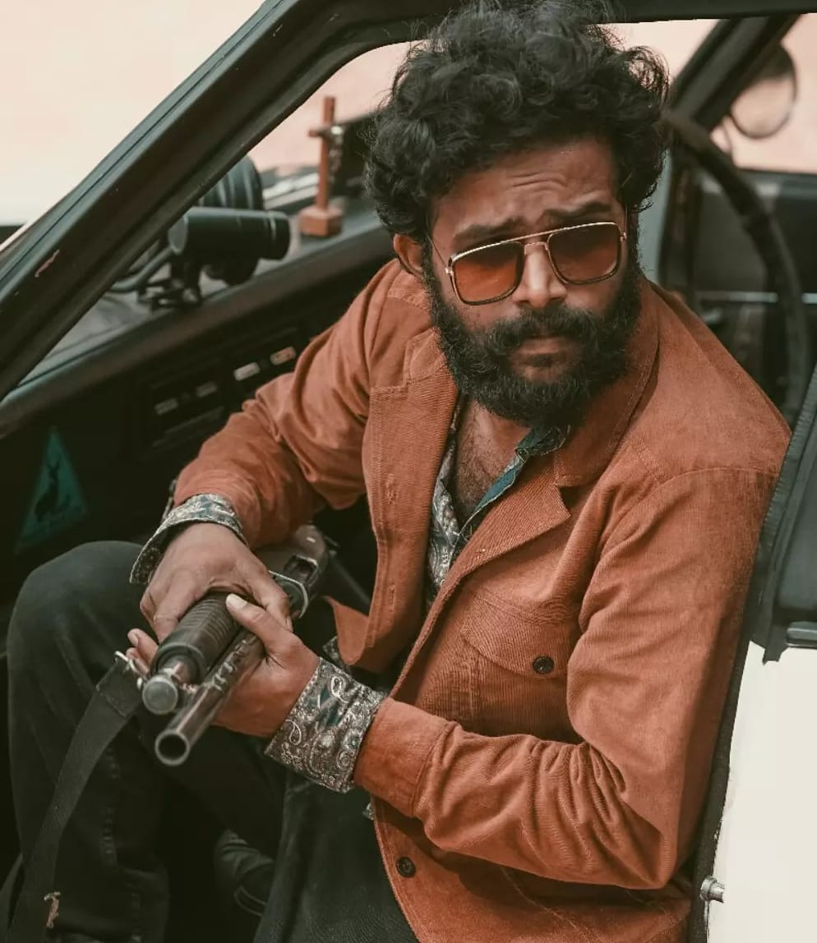
Vineeth Vishwam made his promising big-screen debut in 2017 through Lijo Jose Pellissery’s much-celebrated Crime Drama Angamaly Diaries. The film written by Chemban Vinod Jose received critical acclaim and went on to become a massive commercial success. His natural performance as a hot-headed youngster from Angamaly was lauded by the critics and audience alike. Following that, Vineeth made a notable cameo appearance in Girish A D’s Thaneer Mathan Dinangal starring Vineeth Sreenivasan. He ventured into screenwriting along with Kichu Tellus through Ajagajantharam directed by Tinu Pappachan. The out-and-out action movie starring Antony Varghese turned out to be a whopping blockbuster. Vineeth also essayed a significant role in the movie, similar to his debut performance. He was last seen essaying the role of a college professor in the commercially successful venture Super Sharanya.

Swetha Vinod
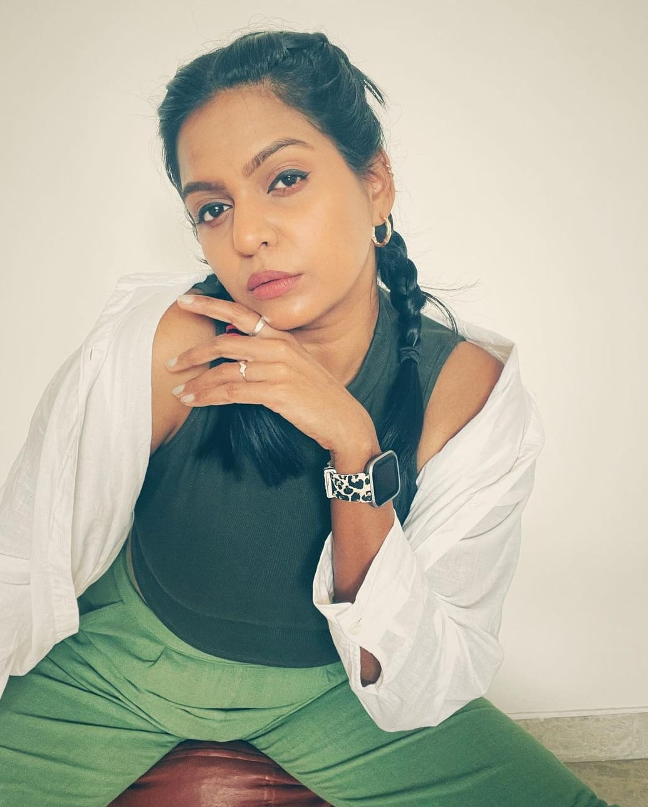
Swetha Vinod is an up-and-coming Model and Actress working predominantly in the Malayalam Film Industry. She gained fame and acclaim for her remarkable performance in Mayanadhi (2017), Velikku Veluppankalam (2020), Aanum Pennum (2021), and Naradhan (2022). After her successful Malayalam career, Swetha made her Hindi Film Debut in 2021 with a character role in Kabir Khan’s revered Sports Drama 83. In the movie, she shared the screen with Ranveer Singh, Jiiva, and Saqib Saleem. And her remarkable performance as a demure South Indian girl was much appreciated.

Amala Mathew
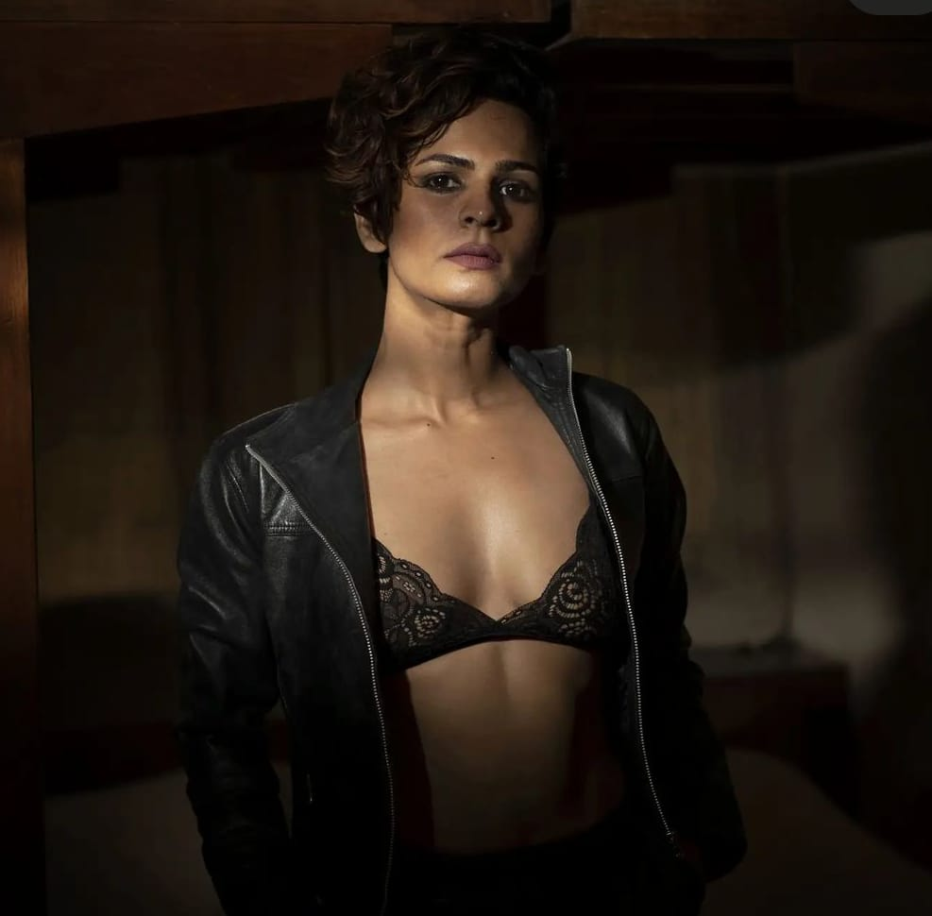
Amala Mathew, a renowned face in Malayalam Film Industry, started her acting career with Vishnu Narayan’s Action-Thriller Maradona in 2018. Shortly after she ventured into Kannada Film Industry in 2019 with Seetharama Kalyana starring Nikhil Gowda. Her subsequent films in Kannada include Comedy Horror Gimmick (2019) and Fantasy Action Film Bhajarangi 2 (2021). After her exceptional stint in Mollywood, next Amala will be seen making her Hindi Film Debut with Neum.

Shylaja P Ambu
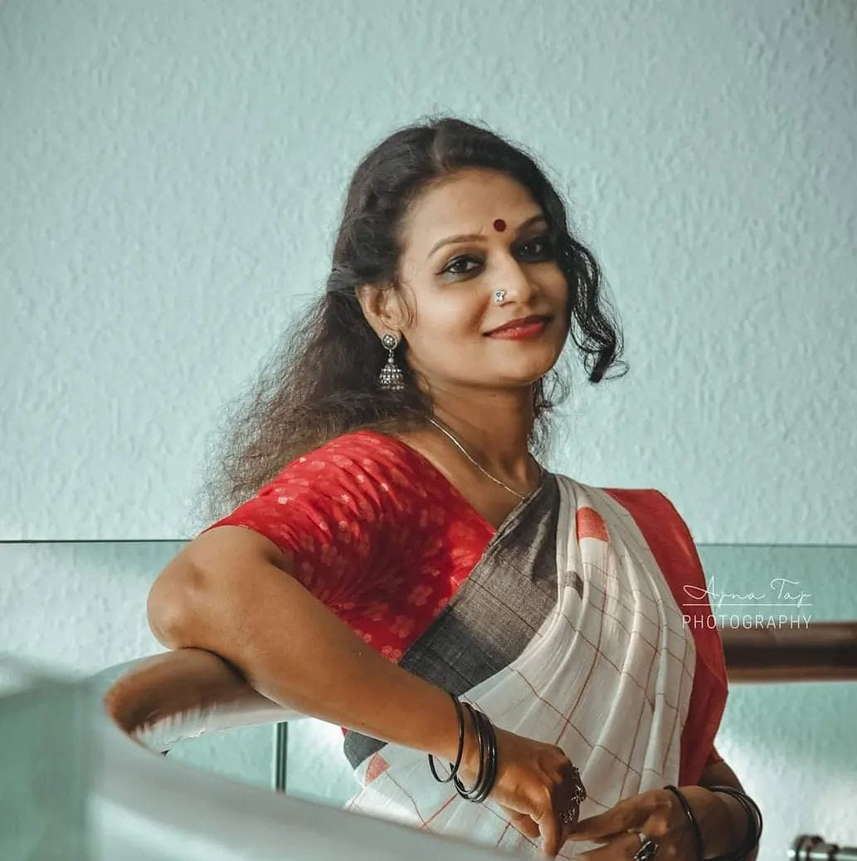
Shylaja P Ambu is an Indian Film Actress with a strong foothold in the Malayalam Film Industry. She rose to fame in 2018 with her strong character role in the social satirical film Aabhaasam written and directed by Jubith Namradath. Next, she essayed the role of Chandrika in the 2021 Investigative Thriller Cold Case featuring Prithviraj in the lead role. Later on, she acted in Arun Vaiga’s Drama Film Upacharapoorvam Gunda Jayan starring Saiju Kurup. Shylaja’s next film to hit the big screen is the much-anticipated Abrid Shine’s Mahaveeryar with Nivin Pauly and Asif Ali.

Rahul Nair
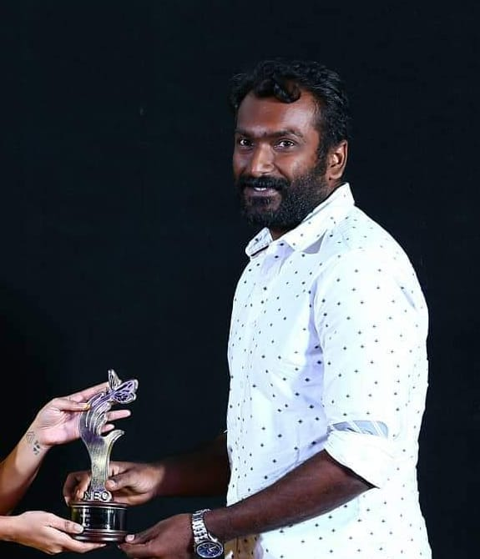
Rahul Nair is an Indian Actor working mostly in Malayalam Film Industry. He gained prominence as Jayasankar in the 2018 romantic comedy film Kamuki written and directed by Binu Sadanandan. Following that, he worked in Rahul Ramachandran’s Comedy-Thriller Jeem Boom Bhaa in 2019. His career peaked in 2021 when he got to share the screen with Mammotty in Bobby & Sanjay’s Political Thriller One. Rahul was last seen in Suresh Gopi’s Action Thriller Kaaval written and directed by Nithin Renji Panicker.

Cast Details

In addition to the primary cast, around 20 accomplished artists from the film and theatre fraternity have made indispensable contributions to the movie.

Music

The original soundtrack of the film is composed by Music Directors Arun N V, Ayaz Ismail, and Sai Balan. With something for everyone, the Gun & Roses album has 6 riveting songs in English, Malayalam, and Tamil language. For technical excellence, the English song was programmed and recorded in the USA.

Film Crew

Writer & Director: Afvin
Producer: Kudurkars Creative World
Camera: Himal Mohan & Agrah Kottarathil
Editor: Hari Devaki
Di: Thomas Kurian
Mixing: Suvin Das
Final Mixing: Bibin Jose
CG: Spectre
Music: Arun NV. Ayaz Ismail. Sai Balan
Lyrics: Nidish Naderi. Shano. Aju Sajan.
Singers: Keerthana, Akriti Verma, Vrusha, NV Arun, Sufail Ahammed, Sai Balan
Art: Amalesh Mk
Makeup: Kiran
Recordist: Sooraj Rajan. Denson Dominic

You can reach us at kudukarscreativeworld@gmail.com or 9535601936

