Bharath: Phase - 4:
Developer Name: Dharmesh
Project Type: Fixed Price

- Create Post: Posts can be created from event detail and from user profile page.
- Create Post API: Need an API to create post from event detail and from profile page
- Request Body: [created user id, tagged user_id / tagged event_id, title, description, image, ashtags]
- Created user id : who creates the post
- tagged user_id : users who are tagged in the post [should support multiple users – maximum up to 25]
- target event_id : when post is created in an event detail page
- title – title for the post
- description – description for the post
- image – images for the post [should support multiple images]
- ashtags – user can enter #tags for the post. Ex: #ganesh [should support multiple #tags]

Mobile Design:

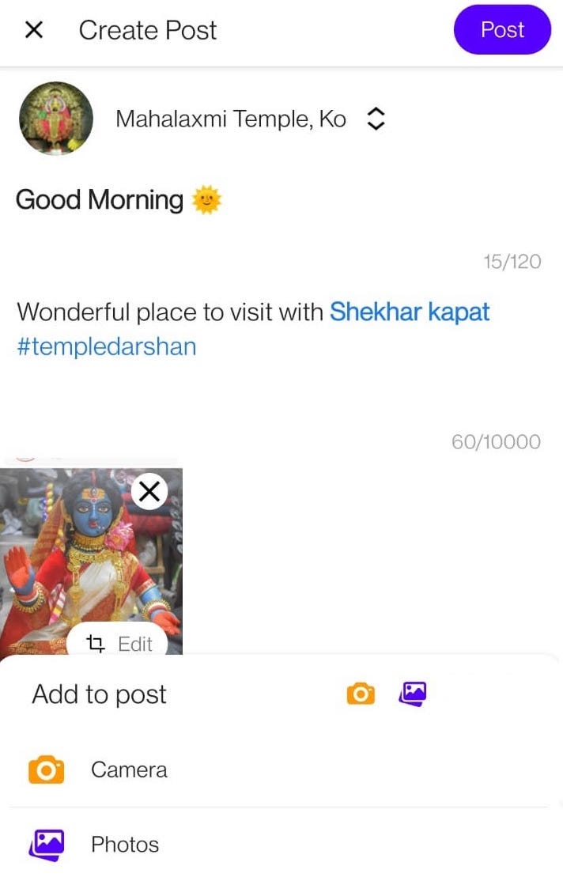
- Update Post API: Need an API to edit post from event detail and from profile page

- Delete Post API: Need an API to delete the post from detail and from profile page.
- Post can be deleted by who created the post
- Posts can also be deleted by event organizer

Admin Panel:
- Created Posted should be displayed in admin panel.

- Profile of users should have 4 filters / Tabs- Events, Created Posts, Tagged Posts and Details

- Events filter / Tab : Current admin panel data needs to be populated [No change needed]

- Created Posts filter / Tab : All created posts by the user will be displayed here.
- Admin can Edit / Delete the post
- All the metadata of the posts needs to be displayed [Title, description, tagged_event, tagged users, #tags, images, likes count, comments]
- Admin should be allowed to edit and delete the comments
- Latest created post will be displayed at the top

- Tagged Posts filter / Tab: All tagged posts to the user will be displayed here.
- Admin can Edit / Delete the post
- All the metadata of the posts needs to be displayed [Title, description, tagged_event, tagged users, #tags, images, likes count, comments]
- Admin should be allowed to edit and delete the comments
- Latest created post will be displayed at the top

- Details filter / Tab: [Mentioned in below 6th Points]
- Need to display Users details in user tabs
- Admin should be able to edit and delete user details

- Get Post: Need API to get all posts based on,
- Users Created Post: API which will return all created posts for a user id.
- Request Body - Passing User_Id
- Response – List of posts created by user with latest post as first item [Each post item will have title, description, images, tagged users, tagged event, ashtags, like count, comments with metadata]
- Users Tagged Post: API which will return all tagged posts for a user id.
- Request Body – Passing User_id
- Response – List of posts which are tagged to a user with latest tagged post as first item [Each post item will have title, description, images, tagged users, tagged event, ashtags, like count, comments with metadata]
- Event Post: API which will return all posts for an event, event_id
- Request Body – Passing event_Id
- Response - List of posts created from event detail page for a event_id with latest post as first item [Each post item will have title, description, images, tagged users, tagged event, ashtags, like count, comments with metadata]
- Also if Admin is commented, then in comments metadata we need to have tag Admin if that comment is from event organiser

Mobile Design:
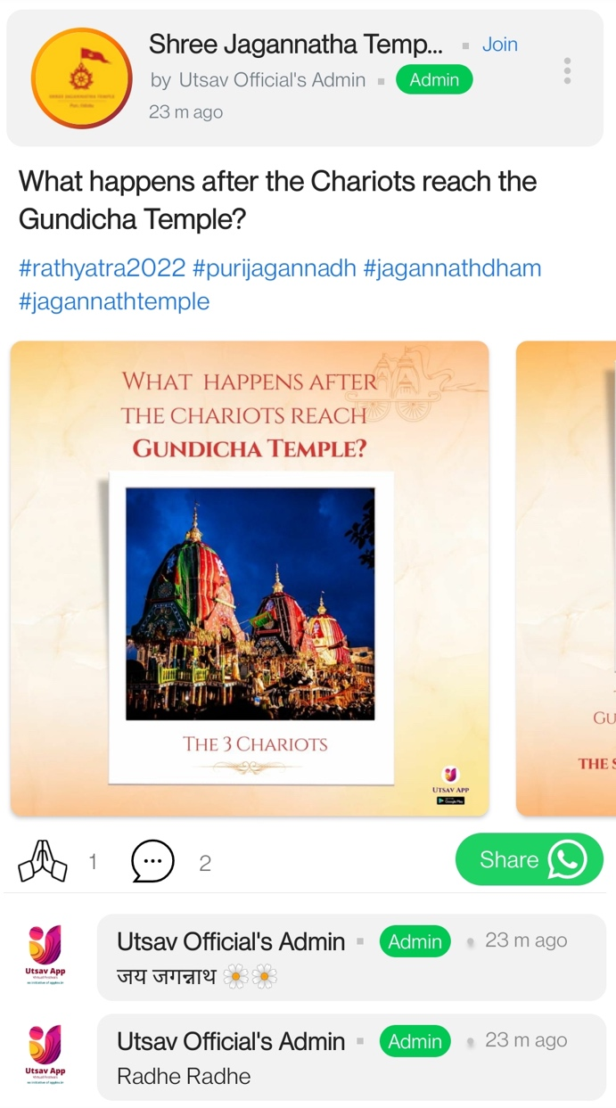

- Like and Comment API:
- Like API : Need API to like a post.
- Request Body : Parameters passed will be Post_id, like_true, user_id
- Response : Success
- Comment API : Need API to comment in a post
- Request Body : Parameters passed will be post_id, user_id, comment text, date and time of the comment
- Response : Success

Note: In all API response, metadata for like = like count [numeric number] and metadata for comments = commented user full details, commented text, commented date and time (1y/ 1m / 2w, 7d, 1d, 23h, 2m, just now)

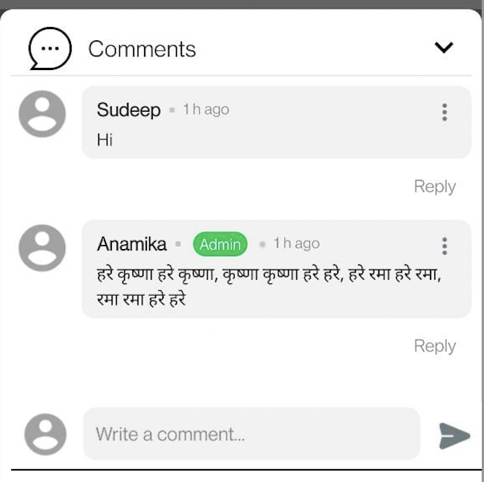

- Unlike API: Need API so that user can unlike the liked post

- Update / Edit Comment API: Need API to update /edit the comment

- Delete Comment API: Need an API to delete the added comment

- Tags API: Need API to get of tags list along with no of posts used that tag
All Tags sent while creating event needs to be saved in database. Also save the count of posts which is used that tag.

Request Body: Sending tags string, [minimum 2 character]
Response: Need list of matching tags with that 2 character along with count of posts used those tags

- User Type: We need an API to divide the user as user Type = user or user Type = Organization
Request Body: We will pass user type in string / Boolean value as per your convenient
- All our current users in database should be set default value as user
- After integrating user type API, update the user type accordingly in database
- Once user changes the type from user to organization, then they cannot change back to user [ I think mostly this will be handled in mobile side]
- Again, you need to send UserType also in the user api response [ like in all API where you send users verified, VIP status].

- User Details & Organizations Details API:

- Create User Details API : Need API to create user details and to create Organizations details. Below details we need to capture,
For UserType = User:
- About [Desctiption text]
- Contact info [Mobile number, Email ID]
For UserType = Organization:
- About [Desctiption text]
- Contact info [Mobile number, Email ID]
- Direction [google location URL]
- Timings [Day, timings, Note]: Example Sunday 7 AM till 12 PM and 5 PM till 6 PM. Like this for whole week data. Also Note can be used if organization wants to put some message like Sunday, temple will be close.
- Donation [Description text]
- Pooja / Programs [Title and Amount]. Example : Title: Nitya Deepa, Amount = 50 RS

Note:
- UserType = User, data will be updated in API response instantly because it won’t need any verification
- UserType = Organization, data will be saved in database, but it will start to come only after admin approves from admin panel

- Update User Details API : Need API to edit/update user details and to update Organizations details.

- Delete User Details API: Need API to delete user details and to delete Organizations details.

Admin Changes:
- UserType = Organization details should be displayed in admin panel with status pending.
- Admin can make status to Approved or Rejected and vice versa based on verification
- Admin should be able to Approve back the rejected data and Admin should reject back to Approved data
- There should be easy filter for Admin to filter Pending, rejected and approved status

- Report Post API: Need API to report the post, while reporting user can select the report reasons like Invalid Post, Dirty Post, Spam Post
Request Body: Post Id and reason needs to be passed
Response: Success

Admin Panel Changes:

