- Tutorial Screen & Upsell (Business Calendar)
Reference
a. Weekview and Month View
b. Notes & Agenda
c. Events with Attachments
d. Purchase popup (Last screenshot is current design)
d1. No Ads
d2. Weather Info
d3. Custom attachments
d5. Themes and color codes
d4. Support development
d5. Google Calendar Sync
Free trial for 7 days and price is same as last screenshot

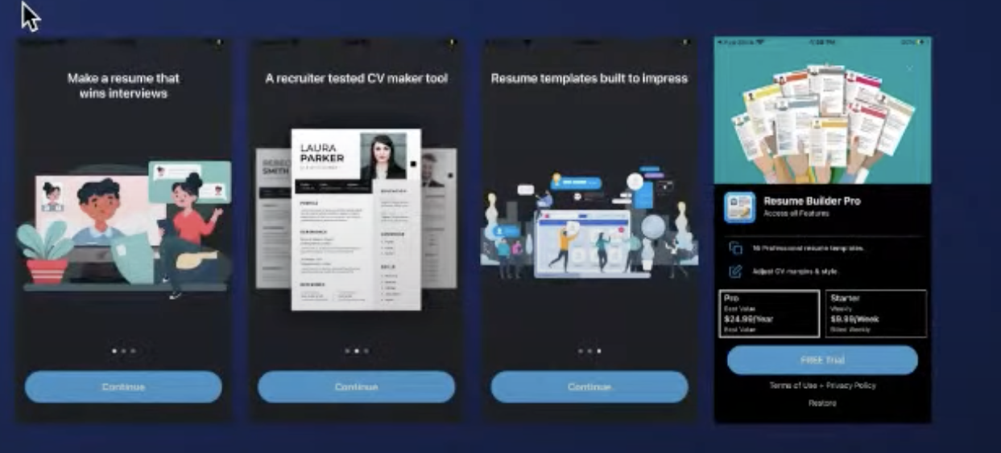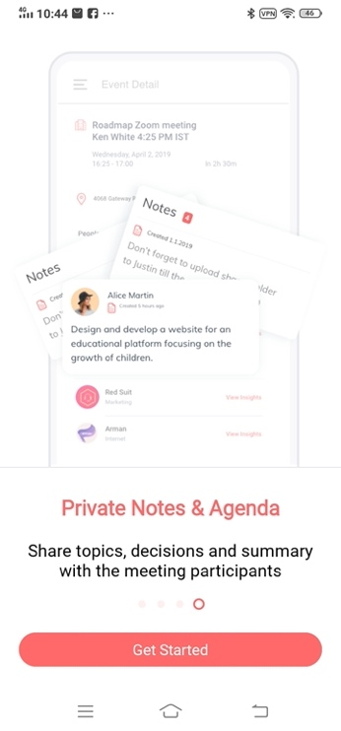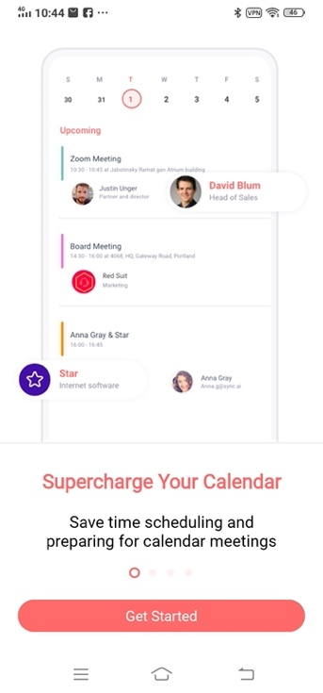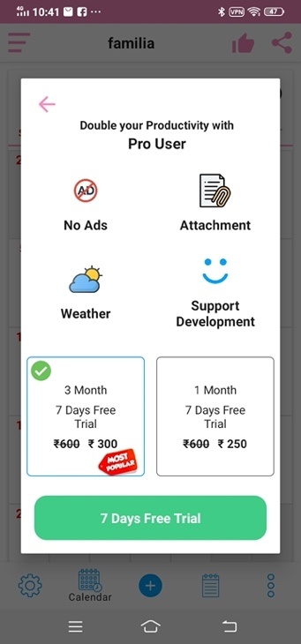

Bharat Calendar changes
2. Bhajans Screen

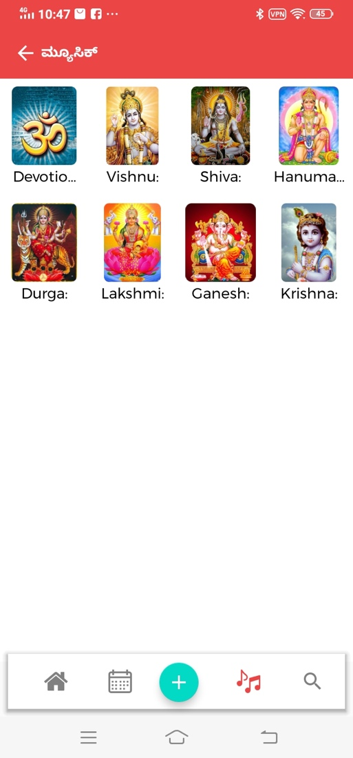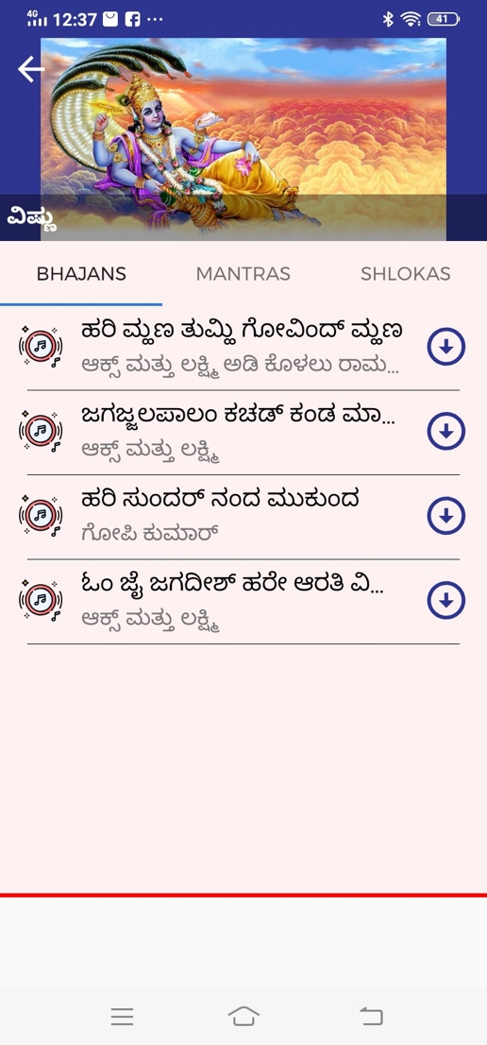
List of gods
List of bhajans, mantras and stotras for that god in next screen
User can download music for offline play
Has a music player

3. Articles screen
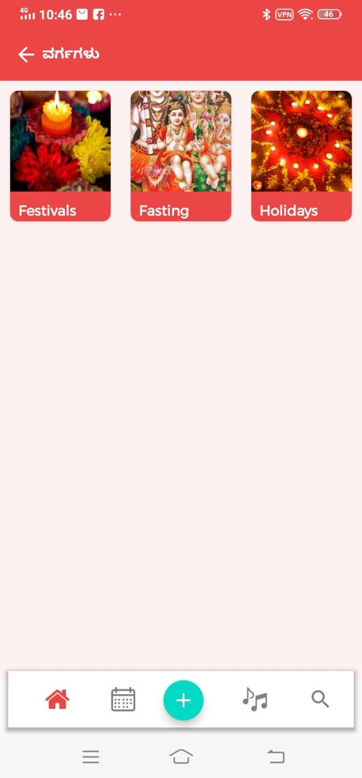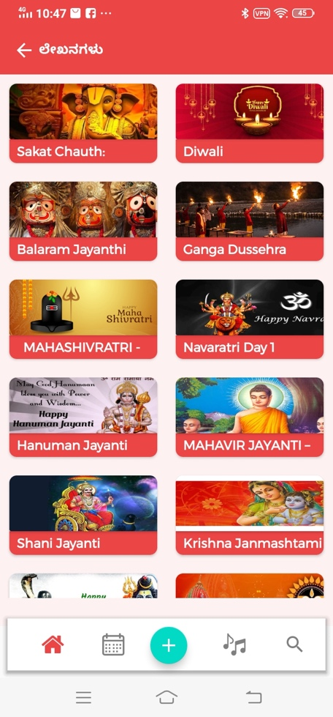
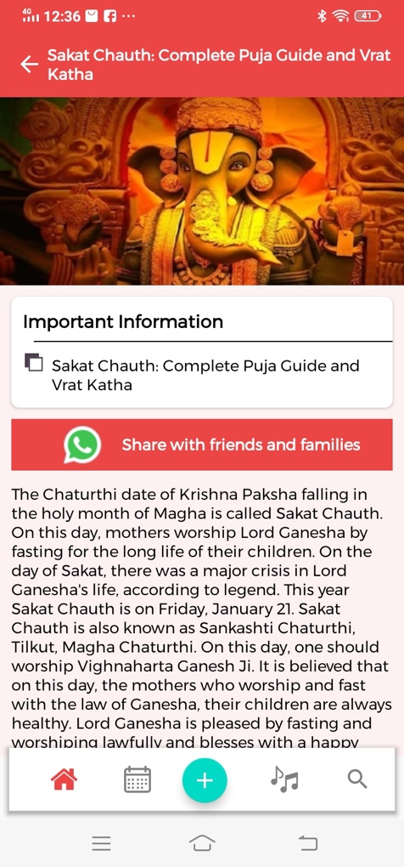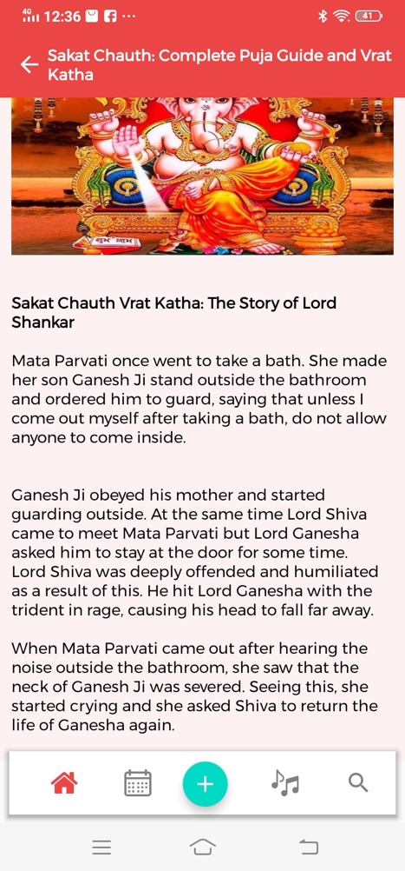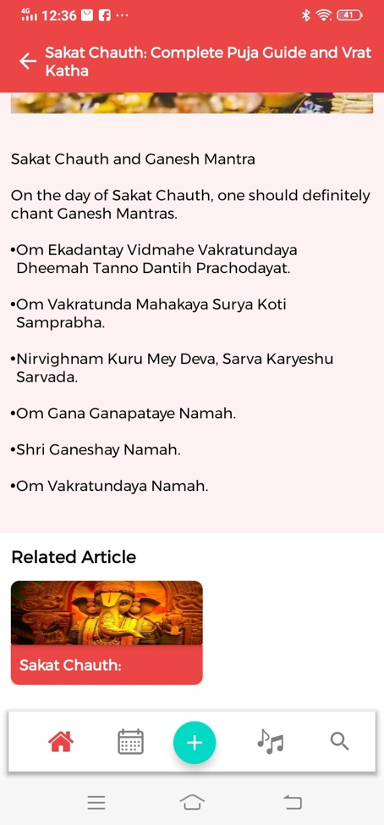
Articles on festivals, fasting days, Holidays, health tips , religious articles etc
Each category will have list of articles with feature image
Article screen has full length of article with different sections (Description, Vrat Katha, Pooja vidhi, Music and bhajans)

4. Event screen
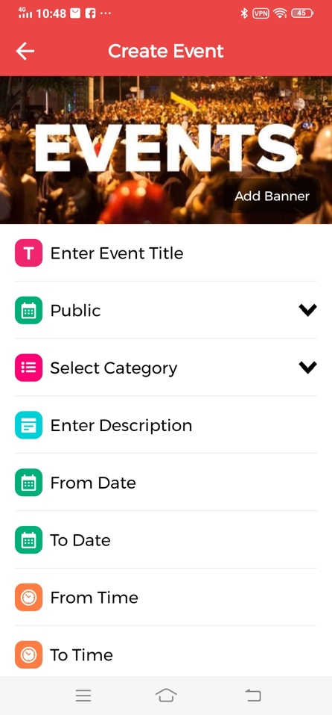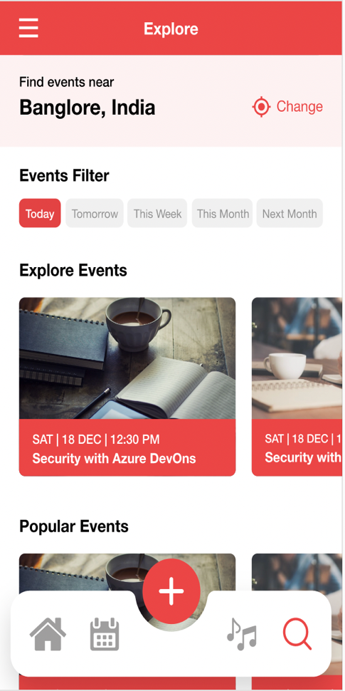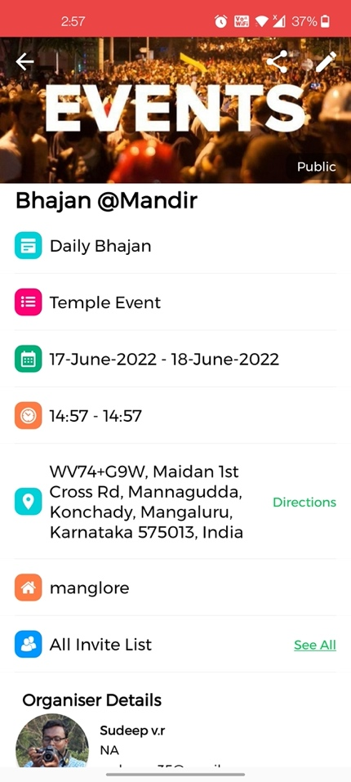

User can create a local event (First reference screen)
Nearby events show up in explore screen (Second reference screen)
Third screen is the event detail page
Note: Current issue in screen, some users did not realise we had to fill the fields while creating the event in first screen, they thought the fields were already filled since it was maybe because of black placeholder texts

