Surya Grahana 2022
The second and last solar eclipse of the year 2022 will take place on October 25, 2022. This eclipse will take place immediately after Diwali. The festival of Diwali or Deepawali is celebrated every year on the new moon of Kartik month. This year Diwali will be celebrated on Monday, October 24 and there will be a solar eclipse on October 25.
An eclipse is a celestial event. When the Moon moves in front of the Sun and is seen from Earth, it may totally or partially obscure the Sun. That is, when the Moon comes between the Sun and the Earth, the Sun's image behind the Moon is covered for some time. This phenomenon is called solar eclipse.
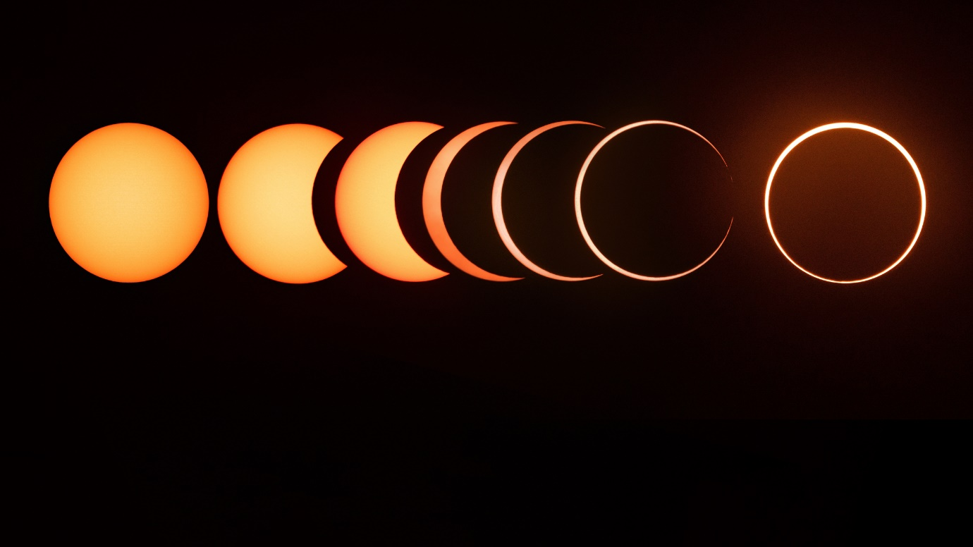
Mythology
The story of the solar eclipse is related to the Samudra Manthan. In ancient times, gods and asuras together churned the ocean. 14 gems came out in this churning. When the nectar came out in the churning of the ocean, a war started between the gods and the demons for this. Then Shri Hari took the incarnation of Mohini and started drinking nectar to the deities. At that time, a demon named Rahu also drank nectar by disguising himself as a deity. Chandra and Surya recognized Rahu and told it to Lord Vishnu. Then Vishnu got angry and severed Rahu's head from his torso. Because Rahu had also drank nectar, so he became immortal. Since then Rahu considers Moon and Sun as his enemies. It hits these planets from time to time. In the scriptures, this phenomenon is called solar eclipse and lunar eclipse.

Where Will the Solar Eclipse Be Seen:
Solar eclipse will be visible in many other countries along with India. Its impact in India will be partially. This eclipse will be visible for a long time in Pakistan, Afghanistan, some countries of Europe and Africa, North Indian Ocean, West Asia etc.
Where Will the Solar Eclipse Not Be Visible:
This eclipse will not be visible from the South-Eastern parts of Africa, East Asia, Australia, North America and South America continents.

Eclipse Period Start and End
Eclipse start time - 04:28 PM
Parmagras or total eclipse - 05:30 PM
The eclipse will end with sunset
Duration of Khandgras or partial eclipse - 01 Hour 13 Minutes 29 Seconds
Sutak starts - 03:17 am
Sutak ends - 05:42 PM

Health Care and Safety
As the sun is the planet's main source of energy and life, a solar eclipse might seriously harm our physical health. In fact, life as we know it would be impossible without the sun. The sun, which is our true Atma Karak, stands for your soul and dignity, your ego, your self-respect, your commitment, your career, your energy, your stamina, your respect in society, your willpower, and your leadership qualities. Young children, the sick, and pregnant women in particular need to be extremely vigilant and aware of their safety during the solar eclipse. Due to the fact that this eclipse will occur on the day after Diwali, we should be more cautious when celebrating. Furthermore, giving to the needy and assisting the impoverished should receive more attention.

Effects on Nation, World and Zodiac Signs
- Partnership disputes in the workplace are also possible.
- Since Libra is an airy sign, problems brought on by natural disasters like wind storms may arise.
- Due to this solar eclipse, problems in alliances may arise as a result of ministerial disagreements as Libra is the sign of collaboration and alliance.
- There may be accusations made against powerful persons in the globe.
- The majority of the issues and effects caused by the solar eclipse will occur or start in the west.
- The conflict between Russia and Ukraine has no end in sight and may even worsen. The soldiers will suffer as a result.

On the day of solar eclipse, the Sun will be in Libra. Along with this, Ketu will be sitting in this zodiac. Apart from this, Moon, Venus will also be sitting in this zodiac. The effects of solar eclipse on the zodiac signs are discussed below:
Aries- Loss of respect and knowledge.
Taurus- State business profit.
Gemini- Economic educational gains.
Cancer- Success in the workplace. New sources of income will open. If there is a desire to buy land, vehicles etc., then buying in this interval will prove to be auspicious.
Leo- Gain of money. The stalled work will start running smoothly.
Virgo- Money loss, family dispute.
Libra - attainment of Lakshmi, fame and fame.
Scorpio - Disease troubles, loss of knowledge.
Sagittarius - child suffering, stress.
Capricorn - Health benefits.
Aquarius - Disturbance in married life, self-aggrandizement.
Pisces - There will be body pain, mental tension. Investment made in business can give very high profits.

